Best Programming Practice
- All values as variables including Fixed, User Inputs, and Results
- Proper naming conventions for all variables
String name = "Eric";
double height = input.nextDouble();
double totalDistance = distanceFromToVia + distanceViaToFinalCity;
- Proper Program Name and Class Name
- Follow proper indentation
- Give comments for every step or logical block like a variable declaration or conditional and loop blocks
- Sample Program 1 - Create a program to check if 3 values are internal angles of a triangle.
IMP => Follow Good Programming Practice demonstrated below in all Practice Programs
Hint =>
- Get integer input for 3 variables named x, y, and z.
- Find the sum of x, y, and z.
- If the sum is equal to 180, print ”The given angles are internal angles of a triangle” else print They are not
// Creating Class with name TriangleChecker indicating the purpose is to
// check if the internal angles add to 180
import java.util.Scanner;

class TriangleChecker {
public static void main(String[] args) {
// Create a Scanner Object
Scanner input = new Scanner(System.in);

// Get 3 input values for angles
int x = input.nextInt();
int y = input.nextInt();
int z = input.nextInt();

// Find the sum of all angles
int sumOfAngles = x + y + z;

// Check if sum is equal to 180 and print either true or false
System.out.println("The given angles " +x+ ", " +y+ ", " + z +
" add to " + sumOfAngles);

if (sumOfAngles == 180) {
System.out.println("The given angles are internal angles of a " +
"Triangle");
} else {
System.out.println("The given angles are not internal angles " +
"of a Triangle");
}

// Closing the Scanner Stream
input.close();
}
}
- Sample Program 2 - Create a program to find the sum of all the digits of a number given by a user.
Hint =>
- Get an integer input for the number variable.
- Create an integer variable sum with an initial value of 0.
- Create a while loop to access each digit of the number.
- Inside the loop, add each digit of the number to the sum.
- Finally, print the sum outside the loop
// Create SunOfDigit Class to compute the sum of all digits of a number
import java.util.Scanner;

class SumOfDigits {

public static void main(String[] args) {
// Create a Scanner Object
Scanner input = new Scanner(System.in);

// Get input value for number
int origNumber = input.nextInt();

// Define variable number and sum initialized to zero
int number = origNumber;
int sum = 0;

// Run while loop to access each digit of number
while (number != 0) {
// Use number % 10 to find each digit of number from last
int digit = number % 10;

// add each digit to sum
sum += digit;

// Remove last digit from number essentially get the quotient
number = number / 10;
}

// Print the sum and close the Scanner Stream
System.out.println("The sum of digit of number:" +origNumber+ " = " +
sum);
input.close();
}
}



Level 3 Practice Programs
- Write a LeapYear program that takes a year as input and outputs the Year is a Leap Year or not a Leap Year.
Hint =>
- The LeapYear program only works for year >= 1582, corresponding to a year in the Gregorian calendar. So ensure to check for the same.
- Further, the Leap Year is a Year divisible by 4 and not 100 unless it is divisible by 400. E.g. 1800 is not a Leap Year and 2000 is a Leap Year.
- Write code having multiple if else statements based on conditions provided above and a second part having only one if statement and multiple logical
# Take user input
year = int(input("Enter a year: "))

# Check if year is valid for Gregorian calendar
if year < 1582:
print("Year entered is before the Gregorian calendar. Please enter year >= 1582.")
else:
print("\n--- Approach 1: Multiple if-else statements ---")
# Approach 1: Multiple if-else
if year % 400 == 0:
print(f"{year} is a Leap Year")
elif year % 100 == 0:
print(f"{year} is NOT a Leap Year")
elif year % 4 == 0:
print(f"{year} is a Leap Year")
else:
print(f"{year} is NOT a Leap Year")

print("\n--- Approach 2: Single if with logical operators ---")
# Approach 2: Single if condition with logical operators
if (year % 4 == 0 and year % 100 != 0) or (year % 400 == 0):
print(f"{year} is a Leap Year")
else:
print(f"{year} is NOT a Leap Year")
- Rewrite program 1 to determine Leap Year with single if condition using logical and && and or || operators
# Take user input
year = int(input("Enter a year: "))

# Check if year is valid for Gregorian calendar
if year >= 1582:
# Single if condition with logical operators
if (year % 4 == 0 and year % 100 != 0) or (year % 400 == 0):
print(f"{year} is a Leap Year")
else:
print(f"{year} is NOT a Leap Year")
else:
print("Year entered is before the Gregorian calendar. Please enter year >= 1582.")
- Write a program to input marks and 3 subjects physics, chemistry and maths. Compute the percentage and then calculate the grade as per the following guidelines
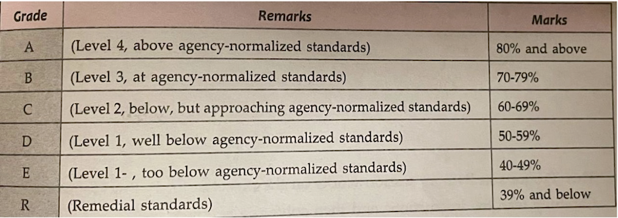
Hint =>
- Ensure the Output clearly shows the Average Mark as well as the Grade and Remarks
# Input marks
physics = float(input("Enter Physics marks: "))
chemistry = float(input("Enter Chemistry marks: "))
maths = float(input("Enter Maths marks: "))

# Calculate total and percentage
total_marks = physics + chemistry + maths
percentage = total_marks / 3

# Determine grade and remarks
if percentage >= 90:
grade = "A+"
remarks = "Outstanding Performance"
elif percentage >= 80:
grade = "A"
remarks = "Excellent Work"
elif percentage >= 70:
grade = "B"
remarks = "Very Good"
elif percentage >= 60:
grade = "C"
remarks = "Good – Can Improve"
elif percentage >= 50:
grade = "D"
remarks = "Pass – Work Harder"
else:
grade = "F"
remarks = "Fail – Needs Improvement"

# Output results
print("\n----- Result -----")
print(f"Physics: {physics}")
print(f"Chemistr
- Write a Program to check if the given number is a prime number or not
Hint =>
- A number that can be divided exactly only by itself and 1 are Prime Numbers,
- Prime Numbers checks are done for numbers greater than 1
- Loop through all the numbers from 2 to the user input number and check if the reminder is zero. If the reminder is zero break out from the loop as the number is divisible by some other number and is not a prime number.
- Use the isPrime boolean variable to store the result
# Take input from user
num = int(input("Enter a number: "))

# Assume initially the number is prime
isPrime = True

# Prime numbers are greater than 1
if num <= 1:
isPrime = False
else:
for i in range(2, num):
if num % i == 0:
isPrime = False
break # No need to check further if divisible

# Output the result
if isPrime:
print(f"{num} is a Prime Number")
else:
print(f"{num} is NOT a Prime Number")

- Create a program to check if a number is armstrong or not. Use the hints to show the steps clearly in the code
Hint =>
- Armstrong Number is a number whose Sum of cubes of each digit results in the original number as in for e.g. 153 = 1^3 + 5^3 + 3^3
- Get an integer input and store it in the number variable and define sum variable, initialize it to zero and originalNumber variable and assign it to input number variable
- Use the while loop till the originalNumber is not equal to zero
- In the while loop find each digit which is the reminder of the modulus operation number % 10. Find the cube of the number and add it to the sum variable
- Again in while loop find the quotient of the number using the division operation number/10 and assign it to the original number. This removes the last digit of the original number.
- Finally check if the number and the sum are the same, if same its an Armstrong number else not. So display accordingly
# Step a & b: Get input and initialize variables
number = int(input("Enter a number: "))
sum_of_cubes = 0
originalNumber = number # To store the original value for comparison

# Step c: Loop until originalNumber becomes 0
while originalNumber != 0:
# Step d: Extract the last digit
digit = originalNumber % 10

# Find cube of the digit and add to sum
sum_of_cubes += digit ** 3

# Step e: Remove the last digit
originalNumber //= 10

# Step f: Compare sum_of_cubes with original number
if sum_of_cubes == number:
print(f"{number} is an Armstrong number.")
else:
print(f"{number} is NOT an Armstrong number.")
- Create a program to count the number of digits in an integer.
Hint =>
- Get an integer input for the number variable.
- Create an integer variable count with value 0.
- Use a loop to iterate until number is not equal to 0.
- Remove the last digit from number in each iteration
- Increase count by 1 in each iteration.
- Finally display the count to show the number of digits
# Step a: Get input
number = int(input("Enter an integer: "))

# Handle negative numbers by taking absolute value
number = abs(number)

# Step b: Initialize count
count = 0

# Special case: if number is 0, it has 1 digit
if number == 0:
count = 1
else:
# Step c-e: Loop until number becomes 0
while number != 0:
number //= 10 # Remove last digit
count += 1 # Increment digit count

# Step f: Display result
print("Number of digits:", count)
- Create a program to find the BMI of a person
Hint =>
- Take user input in double for the weight (in kg) of the person and height (in cm) for the person and store it in the corresponding variable.
- Use the formula BMI = weight / (height * height). Note unit is kg/m^2. For this convert cm to meter
- Use the table to determine the weight status of the person
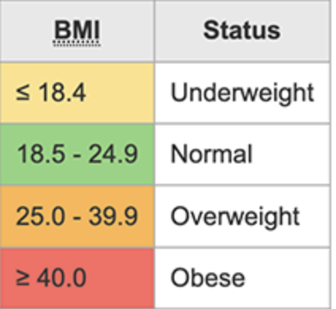
# Step a: Take user input
weight = float(input("Enter weight in kg: "))
height_cm = float(input("Enter height in cm: "))

# Step b: Convert height from cm to meters
height_m = height_cm / 100

# Calculate BMI
bmi = weight / (height_m * height_m)

# Step c: Determine weight status
if bmi < 18.5:
status = "Underweight"
elif 18.5 <= bmi < 24.9:
status = "Normal weight"
elif 25 <= bmi < 29.9:
status = "Overweight"
else:
status = "Obese"

# Display result
print(f"BMI: {bmi:.2f}")
print("Weight Status:", status)
- Create a program to check if a number taken from the user is a Harshad Number.
Hint =>
- A Harshad number is an integer which is divisible by the sum of its digits.
For example, 21 which is perfectly divided by 3 (sum of digits: 2 + 1).
- Get an integer input for the number variable.
- Create an integer variable sum with initial value 0.
- Create a while loop to access each digit of the number.
- Inside the loop, add each digit of the number to sum.
- Check if the number is perfectly divisible by the sum.
- If the number is divisible by the sum, print Harshad Number. Otherwise, print Not a Harshad Number.
# Step b: Take integer input
number = int(input("Enter a number: "))

# Store original number for later comparison
original_number = number

# Step c: Initialize sum
sum_digits = 0

# Step d & e: Loop to extract and add digits
while number > 0:
digit = number % 10
sum_digits += digit
number //= 10 # Remove last digit

# Step f & g: Check divisibility
if original_number % sum_digits == 0:
print(f"{original_number} is a Harshad Number")
else:
print(f"{original_number} is NOT a Harshad Number")
- Create a program to check if a number is an Abundant Number.
Hint =>
- An abundant number is an integer in which the sum of all the divisors of the number is greater than the number itself. For example,
Divisor of 12: 1, 2, 3, 4, 6
Sum of divisor: 1 + 2 + 3 + 4 + 6 = 16 > 12
- Get an integer input for the number variable.
- Create an integer variable sum with initial value 0.
- Run a for loop from i = 1 to i < number.
- Inside the loop, check if number is divisible by i.
- If true, add i to sum.
- Outside the loop Check if sum is greater than number.
- If the sum is greater than the number, print Abundant Number. Otherwise, print Not an Abundant Number.
# Step b: Take integer input
number = int(input("Enter a number: "))

# Step c: Initialize sum of divisors
sum_divisors = 0

# Step d & e & f: Loop to find divisors and sum them
for i in range(1, number):
if number % i == 0: # i is a divisor
sum_divisors += i

# Step g & h: Check if abundant
if sum_divisors > number:
print(f"{number} is an Abundant Number (Sum of divisors = {sum_divisors})")
else:
print(f"{number} is NOT an Abundant Number (Sum of divisors = {sum_divisors})")
- Write a program to create a calculator using switch...case.
Hint =>
- Create two double variables named first and second and a String variable named op.
- Get input values for all variables.
- The input for the operator can only be one of the four values: "+", "-", "*" or "/".
- Run a for loop from i = 1 to i < number.
- Based on the input value of the op, perform specific operations using the switch...case statement and print the result.
- If op is +, perform addition between first and second; if it is -, perform subtraction and so on.
- If op is neither of those 4 values, print Invalid Operator.
# Step a: Create variables
first = float(input("Enter first number: "))
second = float(input("Enter second number: "))
op = input("Enter operator (+, -, *, /): ")

# Step e: Use match-case (Python's switch-case)
match op:
case "+":
result = first + second
print(f"Result: {first} + {second} = {result}")
case "-":
result = first - second
print(f"Result: {first} - {second} = {result}")
case "*":
result = first * second
print(f"Result: {first} * {second} = {result}")
case "/":
if second != 0:
result = first / second
print(f"Result: {first} / {second} = {result}")
else:
print("Error: Division by zero is not allowed.")
case _:
print("Invalid Operator! Please enter one of +, -, *, /.")

- Write a program DayOfWeek that takes a date as input and prints the day of the week that the date falls on. Your program should take three command-line arguments: m (month), d (day), and y (year). For m use 1 for January, 2 for February, and so forth. For output print 0 for Sunday, 1 for Monday, 2 for Tuesday, and so forth. Use the following formulas, for the Gregorian calendar (where / denotes integer division):
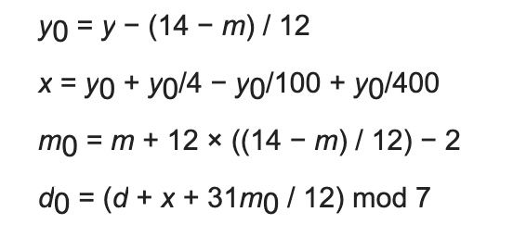
y0 = y - (14 - m) / 12
x = y0 + y0/4 - y0/100 + y0/400
m0 = m + 12 * ((14 - m) / 12) - 2
d0 = (d + x + (31 * m0) / 12) % 7
public class DayOfWeek {
public static void main(String[] args) {
// Taking 3 command-line arguments
int m = Integer.parseInt(args[0]); // month
int d = Integer.parseInt(args[1]); // day
int y = Integer.parseInt(args[2]); // year

// Applying formula
int y0 = y - (14 - m) / 12;
int x = y0 + y0 / 4 - y0 / 100 + y0 / 400;
int m0 = m + 12 * ((14 - m) / 12) - 2;
int d0 = (d + x + (31 * m0) / 12) % 7;

// Output result
System.out.println(d0); // 0 = Sunday, 1 = Monday, etc.
}
}

